### What is the identification and description of each technology?

1. **Artificial Intelligence (AI)** refers to the simulation of human intelligence in and by machines that are programmed to think and learn. AI brings together a variety of technologies such as natural language processing, robotics and machine learning. Its aim is to create systems that can perform tasks which would ordinarily require human intelligence such as but not limited to decision-making, language translation and visual perception(Sheikh et al., 2023).
2. **Extended Reality (XR)** is an umbrella term that puts together augmented reality (AR), virtual reality (VR) and mixed reality (MR). XR technologies blend the digital and physical worlds to create immersive experiences. While AR overlays digital information onto the real world, VR creates a completely virtual environment. MR combines elements from both, thus allowing the real and virtual objects to interact with each other in real-time (Hily et al., 2023).

### What are the likely impacts on computer science or your career?

**As a software engineer:**

1. AI can enhance my career by automating routine tasks, thereby allowing me to focus on more complex and creative aspects related to software development. It can also open up a myriad of opportunities in fields like data science, AI ethics and machine learning (Crompton & Burke, 2023; Slimi, 2023).
2. I can also expand my skill set to develop immersive applications for various industries like gaming, healthcare and education. Doing this helps to make me more versatile (Guilbaud et al., 2021).

**As a father of two:**

1. AI can be helpful in managing my household tasks (they are already present in things like my washing machine, helping me decide which cycles to use based on when and how much laundry I have to do). They also provide my kids with useful educational experiences that can enhance their learning journeys and help them develop the skills they need to build their own careers.
2. XR can offer engaging content for my kids to partake in even from the comfort of their own homes. At this point, given that they are young (two and four years old), I aim to give them as much exposure as possible to the world around them, even if it means from the comfort of our own home (Guilbaud et al., 2021; Vasarainen et al., 2021). Not only will it add to their general knowledge, but it is my hope that the ability to enrich their learning with real-life experiences (even if virtual) will help them to become respectful and capable members of society as they grow up.

### How might the two technologies impact humans, communities, or the world?

**AI:**

**Humans:** AI can improve healthcare through predictive analysis, robotic surgeries and even personalized medication and health plans (Roser, 2022). It can also enhance our daily living with smart home devices and virtual assistants (Alabdulatif, 2024).

**Communities:** Urban planning and infrastructure can be optimized using artificial intelligence, leading to smarter cities with improved energy management, public services and even transportation (Alabdulatif, 2024; Roser, 2022).

**World:** AI may have the potential to address global challenges such as climate change, food security and disaster response with its capabilities in advanced data analysis and in prediction (Alabdulatif, 2024; Roser, 2022).

**XR:**

**Humans:** Immersive learning environments can be created through the use of extended reality. It can also enhance social interactions and entertainment such as games and public hangouts (Iqbal et al., 2023).

**Communities:** XR can facilitate remote collaboration, making it easier for people to work together regardless of their physical locations(Rawas, 2024). Furthermore, XR has been used in psychological research to address various challenges in clinical assessments, intervention and research, making it valuable for psychologists in their service to the community (Rizzo et al., 2021).

**World:** XR technologies are enhancing the tourism experience by allowing virtual tours of historical sites and museums (JISC, 2024) by making visiting historical sites more accessible. This helps in preserving these sites by reducing physical footfall. Furthermore, XR provides immersive gaming experiences which transcend the boundaries of traditional gaming, and encourages education on climate change education (Newton & Annetta, 2024).

### Which course outcomes have you achieved so far, and which ones remain?

I am confident that I have achieved all five course outcomes.

**Course Outcome 1:** Employ strategies for building collaborative environments that enable diverse audiences to support organizational decision making in the field of computer science.

* The most prominent example of this is my use of Git and GitHub throughout this course. In the real world, version control allows me to work collaboratively with other developers and in some cases, members of cross-functional teams and with stakeholders of a given project.

**Course Outcome 2:** Design, develop, and deliver professional-quality oral, written, and visual communications that are coherent, technically sound, and appropriately adapted to specific audiences and contexts.

* Every week, I have written milestones and journals that reflect upon my work in this course and my thought process for the career that lies ahead of me following the completion of my degree. The former encompasses descriptions of the work that I submit as part of the enhancements I complete every week. These descriptions are written so that the general public – regardless of their knowledge of specific technology – can easily comprehend and understand the work that I have done. In addition, my weekly submissions also include a README.md file which clearly details how to access both the original and enhanced versions of my project. I have also taken the extra step to deploy my web application so that it can easily be accessed through a link. This deployment took place on Vercel, which is an easy-to-use platform.

***Figure 1: Vercel hosts my website at the moment.***

**Course Outcome 3:** Design and evaluate computing solutions that solve a given problem using algorithmic principles and computer science practices and standards appropriate to its solution, while managing the trade-offs involved in design choices.

* I achieved this course outcome predominantly in my first enhancement. In the first enhancement, I identified the limitations of the HTML, CSS and JavaScript website that I had initially created, such as maintainability and scalability. I chose Next JS for its server-side rendering, Tailwind CSS for utility-first styling and TypeScript for type safety and better code quality. In doing this, I also planned the architecture of my application by deciding on the components that I had to use, my pages and the flow of data across the destinations page in particular. I applied algorithmic principles – particularly focusing on scalability, correctness and readability – to build a web app that I could continue to grow and change depending on my needs and what my readers want to see in the future.

***Figure 2: Effectively handling data fetching and state management, ensuring the code behaves correctly under various conditions such as loading, error and successful data fetch.***

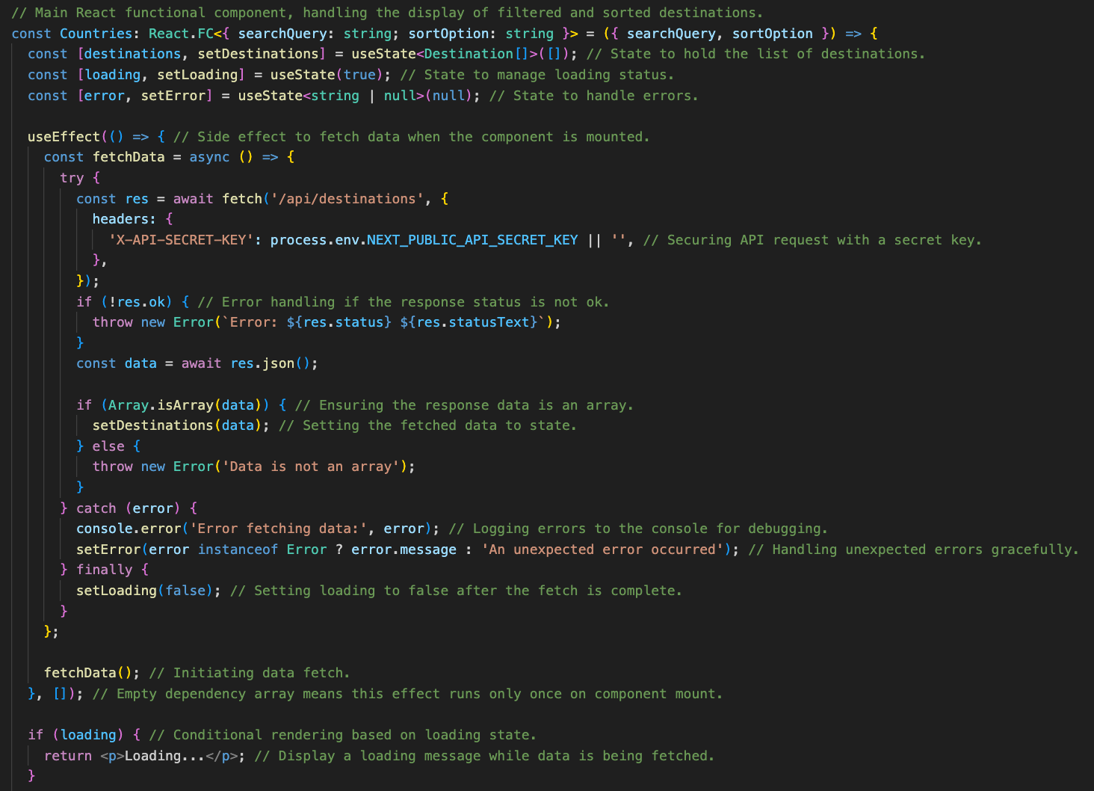

The trade-offs that I had to manage include the benefits of server-side rendering with the complexity that it added to the development process (particularly in the learning curve between React JS and Next JS, Tailwind and TypeScript). I also managed the trade-off between quick development using Tailwind CSS and maintaining clean, readable code with TypeScript.

**Course Outcome 4:** Demonstrate an ability to use well-founded and innovative techniques, skills, and tools in computing practices for the purpose of implementing computer solutions that deliver value and accomplish industry-specific goals.

* By using Next JS 14, I took advantage of a powerful React framework that supports server-side rendering, static site generation and API routes. Implementing Tailwind CSS demonstrates my ability to create responsive and maintainable designs efficiently, and favoring TypeScript over vanilla JavaScript demonstrates my commitment to writing type-safe code, reducing bugs and also improving my code quality.
* Converting my site to use React components demonstrates my understanding of reusable and maintainable code structures. In keeping with industry-specific goals, I enhanced my user experience with Tailwind CSS and made my website scalable for future use.
* Overall, my transition from HTML, CSS and JavaScript to the more modern stack shows my adaptability and ability to solve problems using innovative solutions.

***Figure 3: The app structure. The 'app' folder constitutes the (components) folder, where all my components are stored.***

**Course Outcome 5:** Develop a security mindset that anticipates adversarial exploits in software architecture and designs to expose potential vulnerabilities, mitigate design flaws, and ensure privacy and enhanced security of data and resources.

* In connecting my database, I realized that I had to protect it from unauthorized access. I achieved this by implementing API key authentication to ensure that only authorized users could interact with the API. Additionally, I stored sensitive information, such as the API secret key, in environment variables to keep them secure and prevent them from being exposed in the source code. To further enhance security, I included middleware to validate the API key before processing any requests, ensuring a consistent and centralized approach to access control. These measures collectively help safeguard my database against unauthorized access and potential security threats.

***Figure 4: Database connection***

## Part 2:

### **References**

Alabdulatif, A. (2024). The Global Impact of Artificial Intelligence (pp. 263–277). https://doi.org/10.1007/978-3-031-56292-1_21

Crompton, H., & Burke, D. (2023). Artificial intelligence in higher education: the state of the field. International Journal of Educational Technology in Higher Education, 20(1), 22. https://doi.org/10.1186/s41239-023-00392-8

Guilbaud, P., Guilbaud, T. C., & Jennings, D. (2021). Extended Reality, Pedagogy, and Career Readiness: A Review of Literature (pp. 595–613). https://doi.org/10.1007/978-3-030-77599-5_41

Hily, A., Dupont, L., Arbelaez-Garces, G., Camargo, M., & Dinet, J. (2023). Evaluation and Validation Process of Extended Reality Applications Developed in an Industrial Context: A Systematic Review. SN Computer Science, 4(5), 637. https://doi.org/10.1007/s42979-023-02089-1

Iqbal, M. Z., Xu, X., Nallur, V., Scanlon, M., & Campbell, A. G. (2023). Security, Ethics and Privacy Issues in the Remote Extended Reality for Education (pp. 355–380). https://doi.org/10.1007/978-981-99-4958-8_16

JISC. (2024). Extended reality in learning and teaching report 2023/24. https://www.jisc.ac.uk/reports/extended-reality-in-learning-and-teaching-report-2023-24

Newton, M. H., & Annetta, L. A. (2024). The Influence of Extended Reality on Climate Change Education. Science & Education. https://doi.org/10.1007/s11191-024-00518-y

Rawas, S. (2024). AI: the future of humanity. Discover Artificial Intelligence, 4(1), 25. https://doi.org/10.1007/s44163-024-00118-3

Rizzo, A. “Skip,” Goodwin, G. J., De Vito, A. N., & Bell, J. D. (2021). Recent advances in virtual reality and psychology: Introduction to the special issue. Translational Issues in Psychological Science, 7(3), 213–217. https://doi.org/10.1037/tps0000316

Roser, M. (2022). Artificial intelligence is transforming our world — it is on all of us to make sure that it goes well. Our World In Data. https://ourworldindata.org/ai-impact

Sheikh, H., Prins, C., & Schrijvers, E. (2023). Artificial Intelligence: Definition and Background (pp. 15–41). https://doi.org/10.1007/978-3-031-21448-6_2

Slimi, Z. (2023). The Impact of Artificial Intelligence on Higher Education: An Empirical Study. European Journal of Educational Sciences, 10(1). https://doi.org/10.19044/ejes.v10no1a17

Vasarainen, M., Paavola, S., & Vetoshkina, L. (2021). A Systematic Literature Review on Extended Reality: Virtual, Augmented and Mixed Reality in Working Life. International Journal of Virtual Reality, 21(2), 1–28. https://doi.org/10.20870/IJVR.2021.21.2.4620